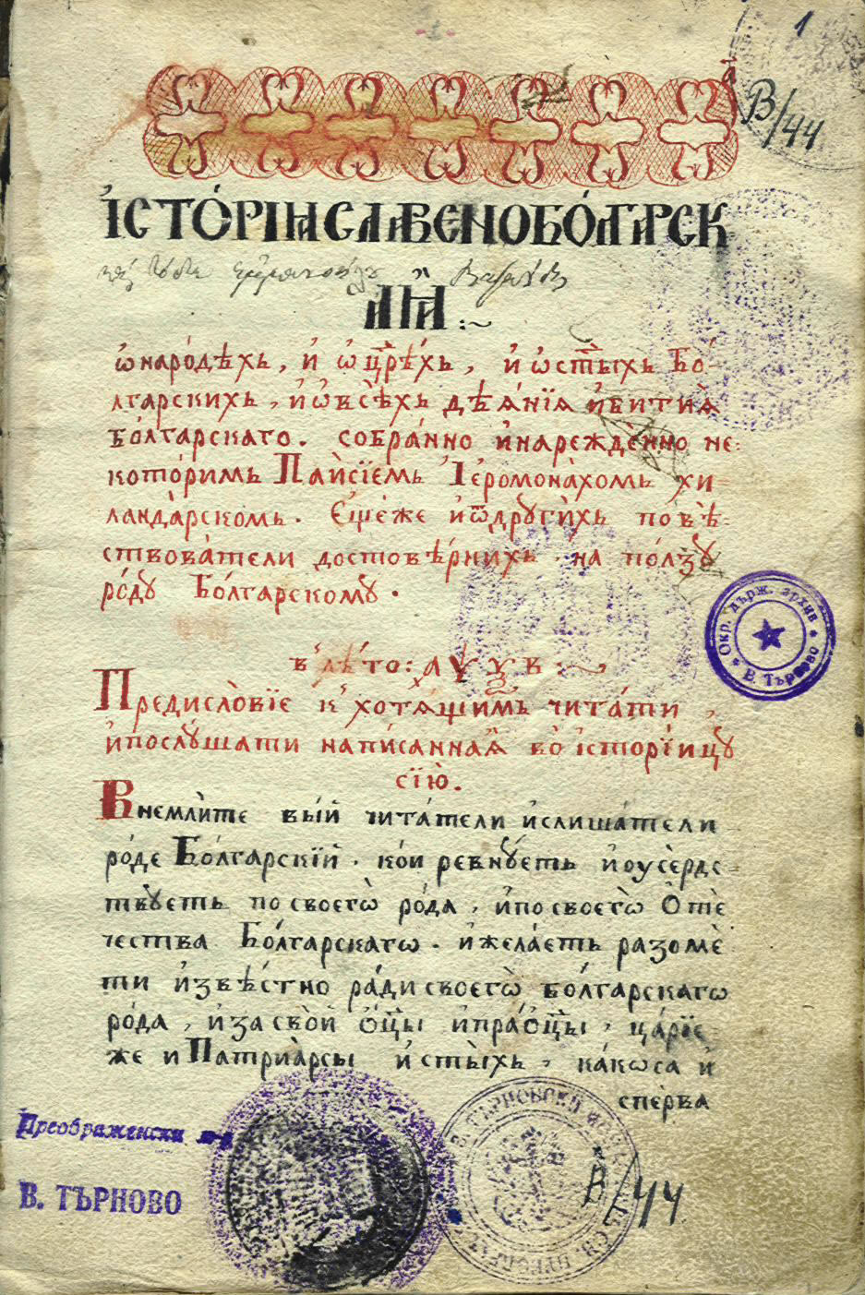

29.03.2011
CONFERENCE
THE BULGARIAN INTERPRETATION OF THE RECENTLY PUBLISHED REPORTS "THE NEW RENAISSANCE" OF THE COMITÉ DES SAGES AND THE "STRATEGIC PLAN ON EUROPEANA 2011-2015"

European Parliament, room P1A002

AGENDA

9.30 - Opening

Emil Stoyanov, Member of the European Parliament

Neelie Kroes, Vice President of the European Commission and European Digital Agenda Commissioner

Doris Pack, Chair of the Culture and Education Committee in the European Parliament

Daniela Petrova, Chair of Culture, Civil Society and Media Committee in the National Assembly of the Republic of Bulgaria

Panel 1: The Interpretation of the reports "The New Renaissance" of the Comité des sages and "Strategic Plan on Europeana 2011-2015"

Moderator - Ms Mariya Baramova, Sofia University

10.00 - 10.20 - Jacques De Decker, Member of the Comité des sages

10.20 - 10.40 - "Europeana and the digital Renaissance"
Yvo Volman, Deputy Head of Unit "Access to Information" at the European Commission

10.40 - 11.00 - "Europeana Strategic Plan 2011-2015"
Harry Verwayen, Europeana’s Business Development Director, EDL Foundation

11.00 - 11.30 - Discussion and coffee break

Panel 2: The Implementation of the reports "The New Renaissance" of the Comité des sages and "Strategic Plan on Europeana 2011-2015" in Bulgaria

11.30 - Opening speech
Dr. Todor Chobanov, Deputy minister of Culture of Republic of Bulgaria

11.40 - 11.50 - "The Participation of the Central Library of the Bulgarian Academy of Sciences in Europeana"
Assoc. prof. Dincho Krastev, PhD, Director of the Central Library of the Bulgarian Academy of Sciences

11.50 - 12.00 - "Digital and information technologies in the Bulgarian National Library to help the Bulgarian and European citizens"
Senior Ass. Aneta Doncheva, Deputy Director of the Bulgarian National Library "St. Kiril and Metodii", Assoc. prof. Cwetanka Pancheva, PhD, Head of Unit "Digital Library" of the Bulgarian National Library "St. Kiril and Metodii", Sofia

12.00 - 12.10 - "Organisational, technical and financial problems of inclusion of museum pieces from Bulgaria in Europeana"
Assoc. prof. Cvetana Kjoseva, PhD, Deputy Director of the National History Museum, Sofia

12.10 - 12.20 - "SUDigital - academic challenges and development of digitalisation in Bulgaria"
Assoc. prof. Todor Popnedelev, PhD, Deputy Dean of the History Faculty of the Sofia University "St. Kliment Ohridski", manager of the project SUDigital, Dobromir Dobrev - coordinator of the project SUDigital

12.20 - 12.30 - "The Varna Library - the way ahead after Europeana Local"
Emilia Staneva-Milkova - Director of the Regional Library "Pencho Slaveikov", Varna

12.30 - 12.40 - "Trends and opportunities for the Public Library "Ivan Vasov" for presenting the Bulgarian cultural heritage and contemporary literary works in a virtual environment"
Assoc. prof. Radka Koleva, PhD - Director of the Public Library "Ivan Vasov", Plovdiv

12.40 - 12.50 - "Using objects of cultural heritage by the means of digital technologies - a view of the Bulgarian legislation and the "New Renaissance of Europe"
Assoc. prof. Veselina Maneva, PhD, Institute for Legal studies, Bulgarian Academy of Sciences, Sofia

12.50 - 13.00 - "Web initiatives close to Europeana's idea and practice"
Assoc. prof. Jivko Ivanov, PhD, Dean of the Philological Faculty in Plovdiv University "Paisii Hilendarski"

13.30 - 15.00 - lunch

15.30 - 15.40 "How the National Archaeological Museum of the Bulgarian Academy of Sciences reads "The new Renaissance" and the museum's future participation in Europeana"
Pavlina Ilieva - Funds Department, National Archaeological Institute of the Bulgarian Academy of Sciences, Sofia;

15.40 - 15.50 - "The National Museums Fund and the European Digital Renaissance - the parallels and intersections in cyberspace"
Prof. Vera Boneva, PhD, University of Library and Information Technology, Sofia

15.50 - 16.00 - "Europeana - a priority project in the policy to digitize archives of the Bulgarian Heritage"
Dr. Milena Todorakova, Expert, National Agency "Archives", Sofia

16.00 - 16.10 - "Technological Expertise and Knowledge Transfer in Digital Libraries, IMI-BAS"
Senior assistant Kalina Sotirova, Institute for mathematics and informatics, Bulgarian academy of sciences, Sofia

16.10 - 17.00 - Discussion

